**REPORT ON GLOBAL HEALTH EXPENDITURE ANALYSIS**

1. **Steps taken for cleaning and transforming the data, such as removing duplicates, replacing null values, and addressing data format issues :**
2. Firstly, we have to load our data into Power BI. To identify missing values, duplicates, replacing null values, and other issues, we will select "Transform Data" or "Edit Queries."
3. To handle missing values in power query editor, we went to the Transform Tab option. Here, we used the "Replace Values" option to handle missing values.
4. To remove duplicate records, we use the "Remove Rows" option under the "Home" tab and select "Remove Duplicates."
5. For data formatting we use the "Change Type" option to convert data types, and the "Replace Values" option to correct formatting issues.

After completing the data cleaning and transformation for the given data ,we select the “close & apply” option under “Home Tab” to load the data into the Power BI data model for further analysis and visualization.

1. **Data Modelling :**

In Power BI, we use Data Modelling here, to create relationships between different tables, which enable us to analyse and visualize the data.

Here, we create relationship between the tables for our given data, which can be shown in the following figure:

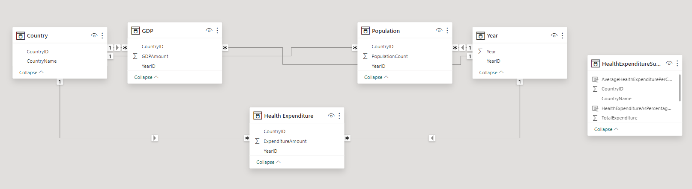

1. GDP table relates to Country table through CountryID Column using Many to One relationship.
2. GDP table relates to Year table through YearID Column using Many to One relationship.
3. Population table relates to Country table through CountryID Column using Many to One relationship.
4. Population table relates to Year table through YearID Column using Many to One relationship.
5. Health Expenditure table relates to Country table through CountryID Column using Many to One relationship.
6. Health Expenditure table relates to Year table through YearID Column using Many to One relationship.
7. **DAX Functions for creating measures and calculated columns :**
8. Here, we create one meaure named as HealthExpenditureSummary by using the following DAX Function : HealthExpenditureSummary = SUMMARIZE('HealthExpenditure',Country[CountryID],'Year'[YearID],"CountryName",MAX(Country[CountryName]),"Year",MAX('Year'[Year]),"TotalExpenditure",SUM('HealthExpenditure'[ExpenditureAmount]),"TotalGDP",SUM(GDP[GDPAmount]),"TotalPopulation",SUM(Population[PopulationCount]))
9. **Here, we create two columns named as AverageHealthExpenditurePerCapita and HealthExpenditureAsPercentageOfGDP** by using the following DAX Functions:

AverageHealthExpenditurePerCapita = DIVIDE('HealthExpenditureSummary'[TotalExpenditure],HealthExpenditureSummary[TotalPopulation])

HealthExpenditureAsPercentageOfGDP = DIVIDE(HealthExpenditureSummary[TotalExpenditure],HealthExpenditureSummary[TotalGDP])*100

1. **Difference between Row Context and Filter Context:**

In Power BI, it is essential to know the difference between Row Context and Filter Context for writing the effective DAX.

These contexts govern how calculations are performed at the row level and based on applied filters.

**Row Context :**

* Row Context is created for each individual row of data in a table.
* When a DAX formula is evaluated within a row context, it operates on a single row at a time.
* This context is automatically created when iterating over rows in a table, such as when using iterators like SUMX() or FITER().

**Filter Context :**

* Filter Context is created when filters are applied to the data, either through slicers, filters, or implicit filters from visualizations.
* Filter Context defines which rows are visible or included in calculations based on the applied filters.
* All calculations in Power BI are evaluated within the context of the filters applied to the data.

Few DAX functions related to filtering discussed below :

**FILTER() :**

* The **FILTER()** function allows you to filter a table or expression based on specified conditions.
* It is commonly used to apply row-level filters within DAX calculations.
* Example : **FILTER(Sales, Sales[Quantity] > 10).**

**CALCULATE() :**

* The **CALCULATE()** function is used to modify the current filter context within a calculation.
* It can be used to override or add additional filters to the existing context.
* Example : **CALCULATE(SUM(Sales[SaleAmount]),Product[Category] =”Electronics”).**

**RELATED() :**

* The **RELATED()** function follows relationships between tables to fetch related values.
* It is used to retrieve values from a related table based on the current row context.
* Example : **RELATED(Product[Category]).**

**ALL() :**

* The **ALL()** function removes all filters from a specified table or column, providing a way to remove filter context within a calculation.
* Example : **CALCULATES(SUM(Sales[SalesAmount]),ALL(Date)).**

1. **Highest health expenditure Country for all the years :** Monaco (56K)

**Lowest health expenditure Country for all the years :** Democratic Republic of the Congo (54)

1. **Percentage of health expenditure as a share of GDP for each country :**

We can understand the percentage of health expenditure as a share of GDP for each country with the help of following figure :

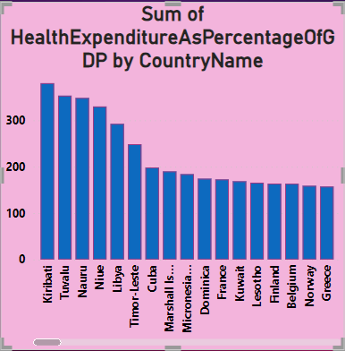

1. **Region, that has the highest average health expenditure per capita :**

We can understand the average health expenditure per capita for each country with the help of following figure :

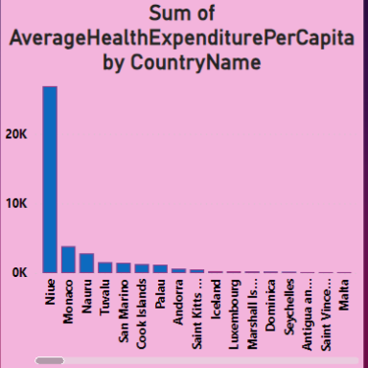

So, from this visual, we can get the region that has highest average health expenditure per capita i.e. “Niue”(26,862).

1. **Field Parameter :**

In Power BI, the "Field" parameter typically refers to a data field within a dataset or data model. When we import data into Power BI, it organizes the data into tables, and each column within those tables represents a field.

Here's how the "Field" parameter be used in Power BI :

**Data Modelling :**

When creating relationships between tables in Power BI's data model, we often use fields from different tables to establish those relationships. For instance, GDP table relates to Country table through CountryID Column using Many to One relationship.

**Visualization :**

In Power BI, we typically drag and drop fields onto the visualization canvas to create visualizations like charts, graphs, or tables. For example, here, we drag the "TotalExpenditure” field,”Country” Field and “Year” Field onto a bar chart's "Values" area to visualize sales data.

**Filters and Slicers :**

Fields can also be used to filter data within visualizations. We can add slicers or filters to a report and use fields to specify which data to include or exclude.

**Calculated Columns and Measures :**

In Power BI, we can create calculated columns and measures based on existing fields. These calculated columns and measures perform calculations using the values in the specified fields. Here, we create one measure named **HealthExpenditureSummary** and two calculated columns named as **AverageHealthExpenditurePerCapita** and **HealthExpenditureAsPercentageOfGDP.**

**Data Transformation :**

When importing data into Power BI, we often perform various data transformation Steps. Here, in our project, we apply some steps like removing duplicates, replacing null values, and addressing data format.

1. **Year that had the highest change percentage in health expenditure : 2020**
2. **Average annual growth rate of health expenditure in 2018 : 0.33**
3. **Trend of health expenditure over the years :**

We can understand the trend of health expenditure over the years with the help of following figure :

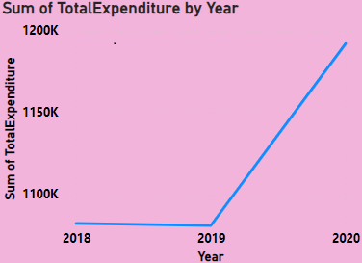

1. **a. Problem Statement :**

In this project, we are going to work on “Global Health Expenditure Dataset”. The objective of this Power BI project is to analyse global health expenditure data to gain valuable insights into various aspects of health spending across countries and regions. The primary goal is to provide a comprehensive and data- driven view of health expenditure trends, its relationships, and identify key patterns. The analysis aims to answer critical questions and support decision- making in the field of global healthcare.

**b. Identifying Factors, KPI :**

In Power BI, Key Performance Indicators (KPIs) are used to monitor and visualize important metrics or performance indicators for a business or organization. KPIs provide a quick and visual way to assess the performance of a specific aspect of the business against predefined targets or goals.

Here, we can create various KPIs like highest health expenditure country, lowest health expenditure country, Total expenditure by country and year. Also , we can create KPIs through measures HealthExpenditureSummary like AverageHealthExpenditurePerCapita by Country and HealthExpenditurePercentageChangeofGDP by country.

1. **Insights :**

**Insights of Global Health Expenditure**

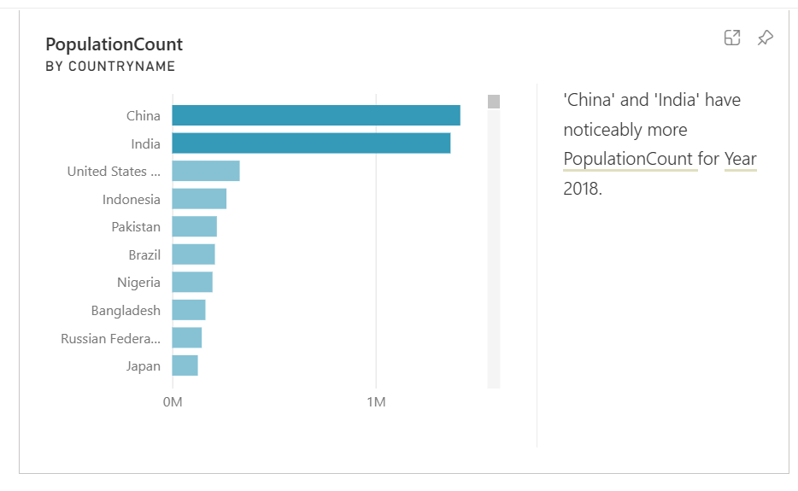

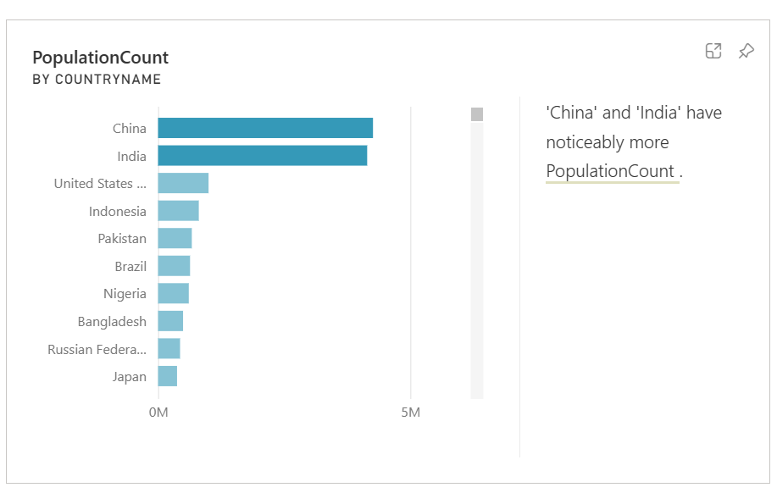

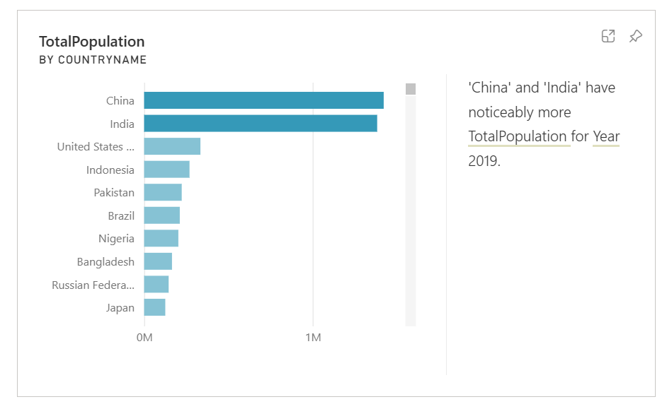

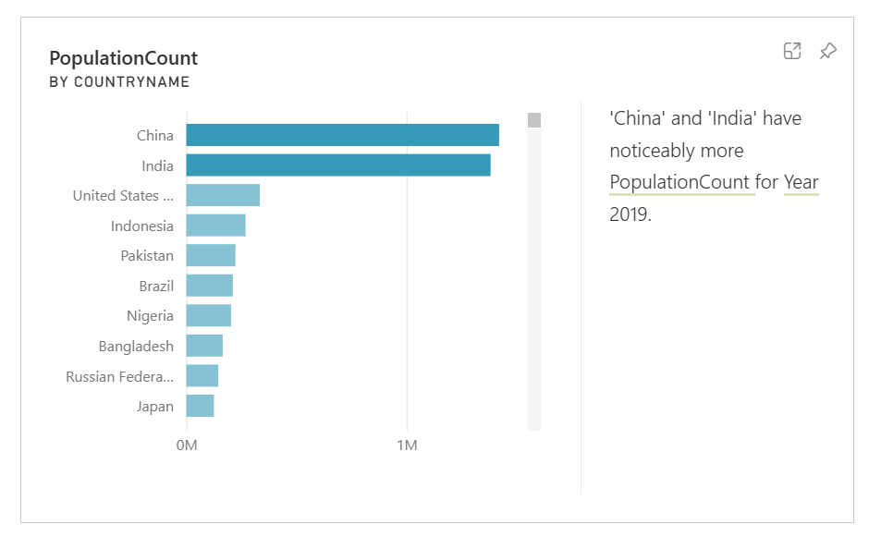

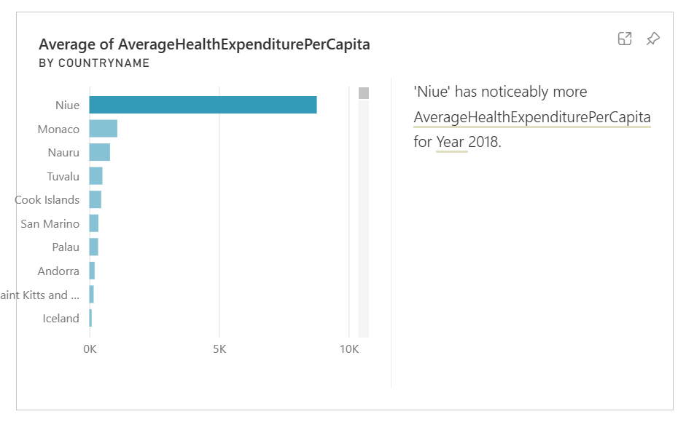

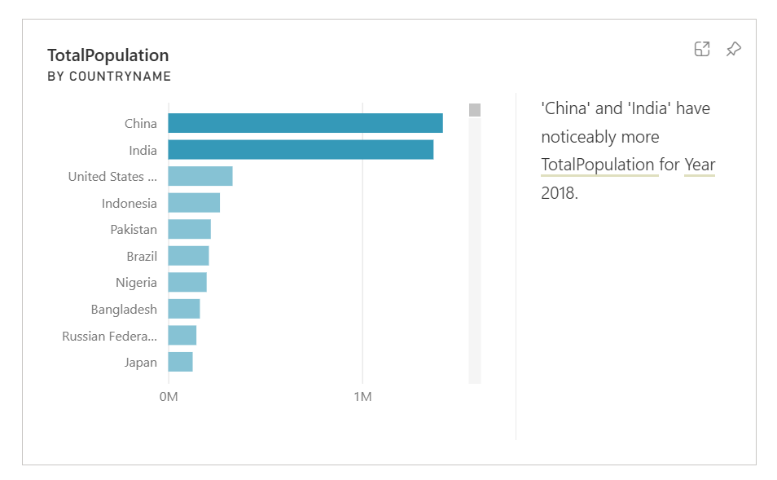

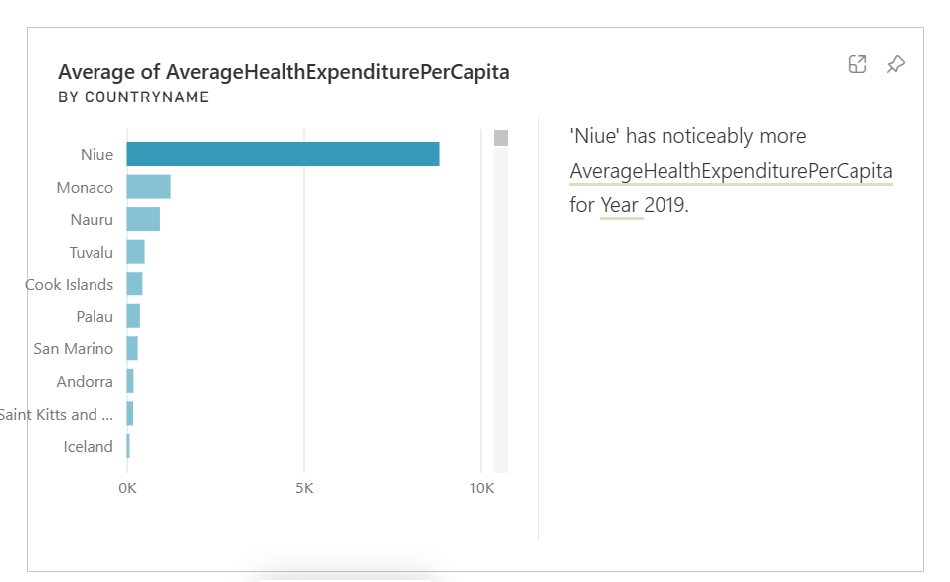

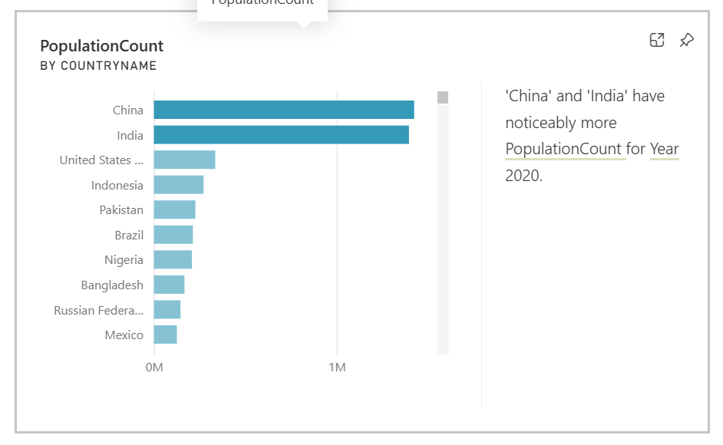

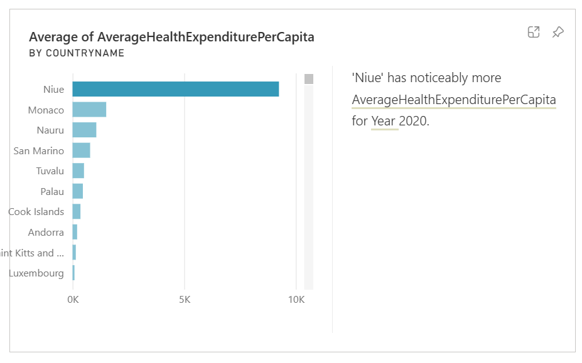

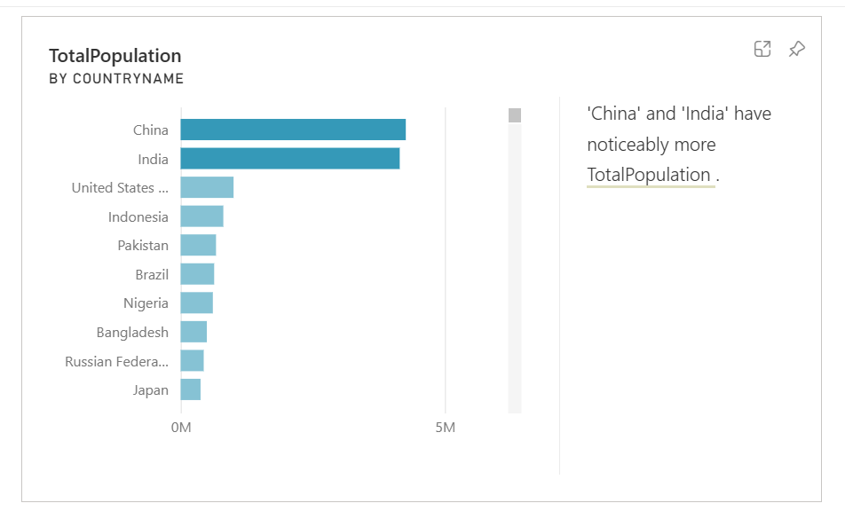

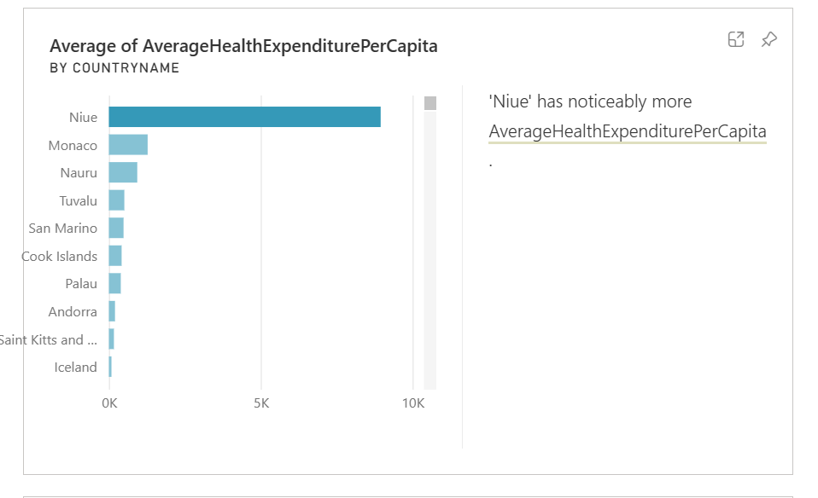

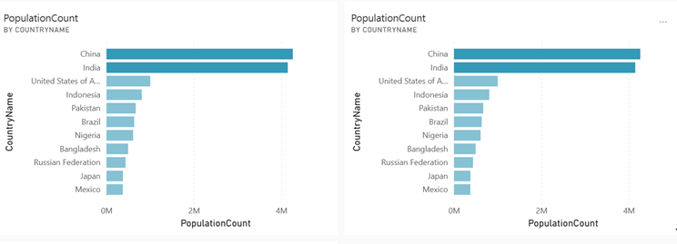

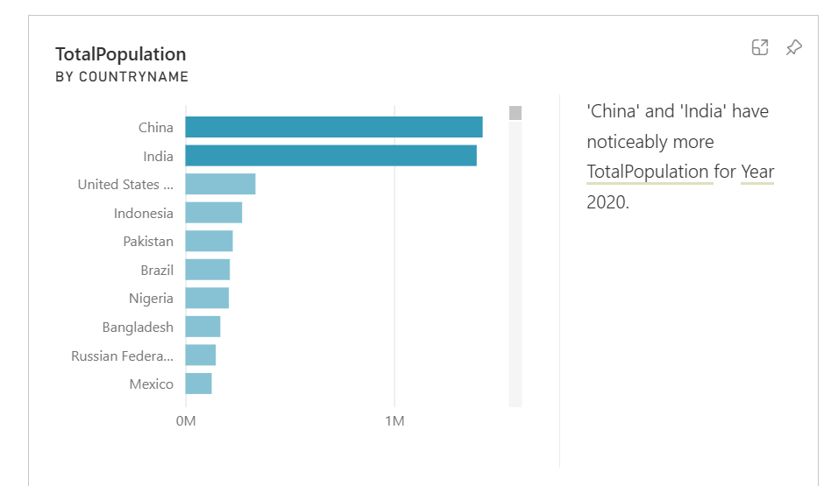

1. **Conclusion :**

In summary, our project focused on analyzing the "Global Health Expenditure Dataset" using Power BI, with the objective of gaining valuable insights into health spending trends worldwide. Throughout our analysis, we aimed to provide a comprehensive understanding of health expenditure patterns, relationships, and dynamics across different countries and regions.

By leveraging Power BI's robust visualization and analytical capabilities, we were able to uncover significant findings regarding global health expenditure. Our analysis revealed varying trends in health spending, highlighting disparities and similarities among different regions and countries. Moreover, we identified correlations between health expenditure and various socio-economic indicators.

The insights generated from this project have the potential to inform decision-makers, policymakers, and stakeholders in the field of global healthcare. By understanding the intricacies of health expenditure patterns, stakeholders can develop targeted interventions and policies to improve healthcare delivery, enhance access to essential services, and address disparities in health outcomes.